**Delete an S3 Bucket**

* Selecting the S3 bucket you want to delete
* Choose the bucket

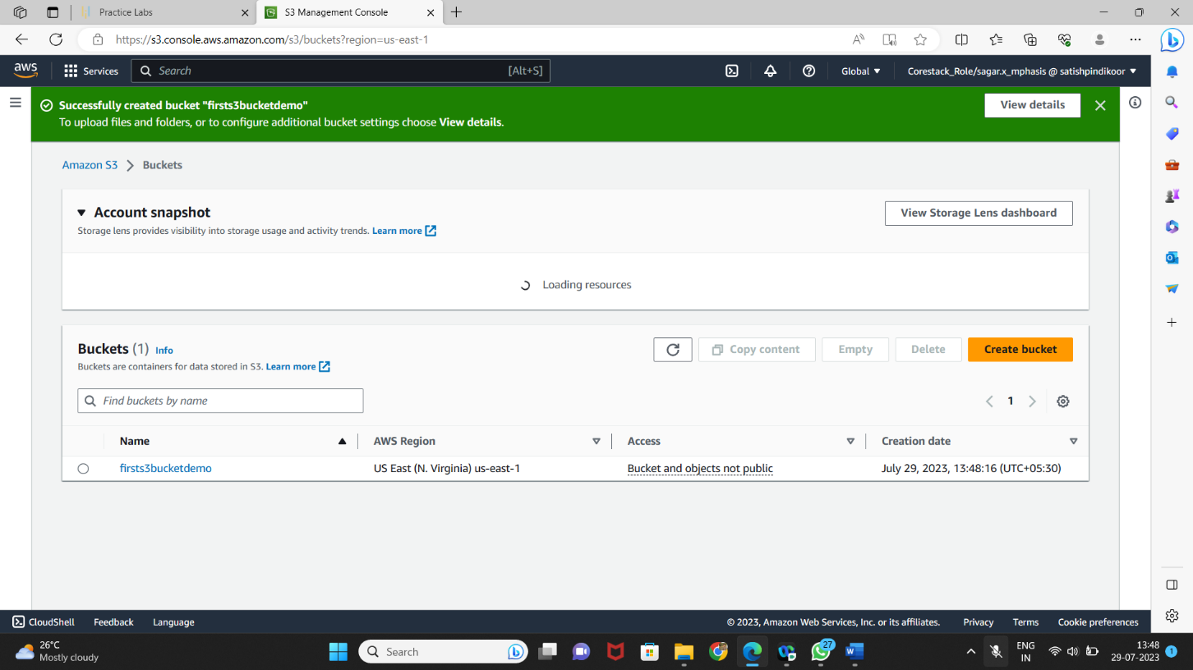

* Deleting the bucket

